**ONLINE ANNEX TO INTRODUCING PWI**

The preliminary dataset used in the study may be found at this GitHub location –

Please reference the Dataset as: E. Evangalista, A. Nazir, R. Sharma & S. Bukhari (2025) Preliminary data from PWI subjects utilizing a medical grade health monitor to track wellness. Available at –

<https://github.com/SalmanResearchAI/PWI-Supplementary-Analysis>

**The following is an extended tutorial on PWI measures.**

Heart Rate Variability (HRV), the variation in time between heartbeats, is a measure of the autonomic nervous system's (ANS) balance and can indicate stress resilience, cardiovascular fitness, and overall health, and with higher HRV generally suggesting better health and adaptability.

* **What HRV Measures:**

HRV is the fluctuation in the time intervals between consecutive heartbeats, not the heart rate itself (which is the number of beats per minute).

* **Autonomic Nervous System (ANS) Balance:**

HRV reflects the interplay between the sympathetic (fight-or-flight) and parasympathetic (rest-and-digest) branches of the ANS.

* [**High HRV**](https://www.google.com/search?sca_esv=176b5c9e7e592193&q=High+HRV&sa=X&ved=2ahUKEwjNv4rT8L6MAxVOOjQIHed-H0wQxccNegQIcBAC&mstk=AUtExfB82iw6zpr3NlYBHINiuS_eHXuqy61nNNJfVyFNhdd8YmBPmkg8uRPKaghPGHgGa46LSymKAZ606Y_CVoJ37cBOpupZslcWvQniNVBERdbPZh8Os1NK7Y9TK-a9BaFpEECJH0EtBcxklpJ-ZldO0Hnq8a2nyQEvtJUSqyVj2RbogHU&csui=3)**:**
  + Indicates a well-functioning ANS, with a good balance between rest and activity.
  + Suggests better cardiovascular fitness and resilience to stress.
  + May be a sign of a good recovery from physical and mental stressors.
* [**Low HRV**](https://www.google.com/search?sca_esv=176b5c9e7e592193&q=Low+HRV&sa=X&ved=2ahUKEwjNv4rT8L6MAxVOOjQIHed-H0wQxccNegQIZhAC&mstk=AUtExfB82iw6zpr3NlYBHINiuS_eHXuqy61nNNJfVyFNhdd8YmBPmkg8uRPKaghPGHgGa46LSymKAZ606Y_CVoJ37cBOpupZslcWvQniNVBERdbPZh8Os1NK7Y9TK-a9BaFpEECJH0EtBcxklpJ-ZldO0Hnq8a2nyQEvtJUSqyVj2RbogHU&csui=3)**:**
  + Can indicate a dominance of the sympathetic nervous system, potentially due to chronic stress, poor sleep, or overtraining.
  + May be associated with increased risk of cardiovascular problems, anxiety, and depression.
  + Can signal a need for more rest and recovery.
* **Factors Influencing HRV:**
  + Lifestyle: Stress, sleep quality, diet, exercise, and alcohol consumption can all affect HRV.
  + Age and Sex: HRV tends to decrease with age, and there can be differences between genders.
  + Medical Conditions: Certain medical conditions and medications can also affect HRV.
* **How to Monitor HRV:**
  + Wearable devices (fitness trackers, smartwatches) can track HRV.
  + Apps and software can analyze data from these devices.
  + Long-term monitoring of HRV trends can provide insights into overall health and fitness.
* **Using HRV Data:**
  + HRV can be a valuable tool for optimizing training and recovery.
  + It can help identify periods of overtraining or under-recovery.
  + It can be used to monitor stress levels and adjust lifestyle habits.
* HRV: What It Is and How You Can Track It

**States of Wellness**

**Restful State** - In the restful state, the individual is typically at rest or engaged in low-stress activities. Weights w₁, w₂, and w₃ are assigned values between 1 and 14.9 to emphasize baseline physiological stability. Key metrics include:

* **Heart Rate Variability:** HRV scores above 50 ms (e.g., RMSSD or LF/HF ratio) suggest a healthy autonomic balance (Shaffer & Ginsberg, 2017). Age and fitness levels influence these scores, with younger individuals often showing higher variability.
* **Breathing Efficacy:** 
  + Balanced Inhalation and Exhalation: Typically 12–20 breaths per minute.
  + Adequate Tidal Volume: Supports proper oxygenation and energy production.
  + Normal Oxygen Saturation: Levels exceeding 95%, measured using a pulse oximeter (Courtney, 2011).
* **Galvanic Skin Response / Electrodermal Activity:** Resting EDA values typically range between 0.5 and 1.5 μS, with occasional transient increases caused by mild stressors (Posada-Quintero & Chon, 2020).

A PWI score in the range of 24–26.5 indicates a stable and healthy state.

*Note: PWI scores in the normal state are subject to individual variations based on age, fitness, and baseline physiological characteristics.*

**Active State** - The active state corresponds to moderate-to-intense physical activities, where weights w₁, w₂, and w₃ range from 15 to 29.9, reflecting physiological adjustments to increased energy demands. Observations include:

* **Heart Rate Variability:** A decline in HRV, with values below 30 ms, reflects heightened sympathetic activity and reduced parasympathetic tone during exertion (Shaffer & Ginsberg, 2017)..
* **Breathing Efficacy:** 
  + Reduced Tidal Volume: Indicating inefficient oxygen delivery.
  + Increased Respiratory Rate: Rapid breathing due to exertion or stress.
  + Reduced Oxygen Saturation: May indicate reduced respiratory efficiency (Courtney, 2011).
* **Electrodermal Activity:** EDA values exceeding 1.5 μS signify increased arousal and stress (Posada-Quintero & Chon, 2020).

A PWI score in the range of 27–29 characterizes this state.

*Note: PWI values in the active state depend on individual fitness and activity levels.*

**Distressed State** - The emergency state occurs during critical health crises or extreme stress. Weights w₁, w₂, and w₃ are set between 30 and 44.9 to account for heightened physiological distress. Indicators include:

* **Heart Rate Variability:** Extremely low HRV, indicative of severe autonomic dysfunction and stress (Ross et al., 2016).
* **Breathing Efficacy:** 
  + Increased Respiratory Rate: Reflecting difficulty in maintaining oxygen intake.
  + Decreased Tidal Volume: Suggestive of restricted airflow.
  + Low Peak Expiratory Flow Rate (PEFR): A marker of respiratory distress (Courtney, 2011).
* **Electrodermal Activity:** Highly elevated EDA values, often exceeding 3.0 μS, denote extreme stress or emergency conditions (Posada-Quintero & Chon, 2020).

A PWI score within 20–22.5 typically indicates a critical state requiring immediate medical intervention.

**We hence conjecture that**

* **In the restful state:** with HRV scores above 50 ms, the PWI score in the range of 24–26.5 indicates a stable and healthy state
* **In the active state:** decline in HRV, with values below 30 ms, reflects heightened sympathetic activity and reduced parasympathetic tone during exertion; PWI score in the range of 27–29 characterizes this state. **So while HRV has reduced, the PWI has increased**
* **In the distressed state:** Extremely low HRV, indicative of severe autonomic dysfunction and stress; PWI score within 20–22.5 typically indicates a critical state requiring immediate medical intervention. So as HRV is extremely low, PWI is also extremely low.

As we see the difference in HRV vs PWI between the active state and distressed state, the question of why the average person cannot have a restful (and not reduced) HRV in the active state?

 Let us now consider long distance (& marathon) Runners**.** They are able to maintain low HR and hence low HRV because of their autonomic nervous system maintaining a balanced state.

Endurance training leads to physiological adaptations across multiple systems, including [cardiovascular](https://www.google.com/search?cs=0&sca_esv=4fc2a90d16b83663&q=cardiovascular&sa=X&ved=2ahUKEwiguN-c_L6MAxWTH0QIHagFBeIQxccNegQIAxAB&mstk=AUtExfBmnwi8dSqwCUKIhGubxScQqW29gaQpFs7L4S8B0wkTNTDTpXS8r0urO4snAML6QeyhiWMKxG7j71WZJRSg1XF-k-w0aRrcktoaYNPnH8dbZ-B0Gn74ZUPOz_o7SQ-ydO33-THuoivljzAdKD3dUvXaFyaqUu16y2TbDJn-tEnMsegxSel64X9Td6xyEpXu2RpPVwoi_C8v45A3NN371X0CIQ&csui=3), [respiratory](https://www.google.com/search?cs=0&sca_esv=4fc2a90d16b83663&q=respiratory&sa=X&ved=2ahUKEwiguN-c_L6MAxWTH0QIHagFBeIQxccNegQIAxAC&mstk=AUtExfBmnwi8dSqwCUKIhGubxScQqW29gaQpFs7L4S8B0wkTNTDTpXS8r0urO4snAML6QeyhiWMKxG7j71WZJRSg1XF-k-w0aRrcktoaYNPnH8dbZ-B0Gn74ZUPOz_o7SQ-ydO33-THuoivljzAdKD3dUvXaFyaqUu16y2TbDJn-tEnMsegxSel64X9Td6xyEpXu2RpPVwoi_C8v45A3NN371X0CIQ&csui=3), [metabolic](https://www.google.com/search?cs=0&sca_esv=4fc2a90d16b83663&q=metabolic&sa=X&ved=2ahUKEwiguN-c_L6MAxWTH0QIHagFBeIQxccNegQIAxAD&mstk=AUtExfBmnwi8dSqwCUKIhGubxScQqW29gaQpFs7L4S8B0wkTNTDTpXS8r0urO4snAML6QeyhiWMKxG7j71WZJRSg1XF-k-w0aRrcktoaYNPnH8dbZ-B0Gn74ZUPOz_o7SQ-ydO33-THuoivljzAdKD3dUvXaFyaqUu16y2TbDJn-tEnMsegxSel64X9Td6xyEpXu2RpPVwoi_C8v45A3NN371X0CIQ&csui=3), [muscular](https://www.google.com/search?cs=0&sca_esv=4fc2a90d16b83663&q=muscular&sa=X&ved=2ahUKEwiguN-c_L6MAxWTH0QIHagFBeIQxccNegQIAxAE&mstk=AUtExfBmnwi8dSqwCUKIhGubxScQqW29gaQpFs7L4S8B0wkTNTDTpXS8r0urO4snAML6QeyhiWMKxG7j71WZJRSg1XF-k-w0aRrcktoaYNPnH8dbZ-B0Gn74ZUPOz_o7SQ-ydO33-THuoivljzAdKD3dUvXaFyaqUu16y2TbDJn-tEnMsegxSel64X9Td6xyEpXu2RpPVwoi_C8v45A3NN371X0CIQ&csui=3), and [cellular](https://www.google.com/search?cs=0&sca_esv=4fc2a90d16b83663&q=cellular&sa=X&ved=2ahUKEwiguN-c_L6MAxWTH0QIHagFBeIQxccNegQIAxAF&mstk=AUtExfBmnwi8dSqwCUKIhGubxScQqW29gaQpFs7L4S8B0wkTNTDTpXS8r0urO4snAML6QeyhiWMKxG7j71WZJRSg1XF-k-w0aRrcktoaYNPnH8dbZ-B0Gn74ZUPOz_o7SQ-ydO33-THuoivljzAdKD3dUvXaFyaqUu16y2TbDJn-tEnMsegxSel64X9Td6xyEpXu2RpPVwoi_C8v45A3NN371X0CIQ&csui=3), enhancing exercise capacity and performance. These adaptations include a stronger heart, lower resting heart rate, improved lung capacity, and enhanced energy production.

**Here is a more detailed breakdown of the adaptations:**

* Cardiovascular Adaptations:
  + **Stronger Heart:** Endurance training strengthens the heart muscle, allowing it to pump more blood with each beat, leading to a lower resting heart rate.
  + **Lower Resting Heart Rate:** The heart beats less frequently at rest, as it becomes more efficient at delivering oxygen to the body.
  + **Increased Stroke Volume:** The heart pumps a larger volume of blood with each beat, improving overall cardiovascular efficiency.
  + **Increased Plasma Volume:** Endurance training increases the volume of plasma in the blood, which can help with oxygen transport and delivery to working muscles.
  + **Improved Capillarization:** More blood vessels (capillaries) grow in the muscles, facilitating better oxygen delivery.
* Respiratory Adaptations:
  + **Increased Lung Capacity:** Endurance training can slightly increase lung capacity, allowing the body to take in and process more oxygen.
  + **Improved Gas Exchange:** The lungs become more efficient at exchanging oxygen and carbon dioxide.
* Metabolic Adaptations:
  + **Enhanced Glycogen Storage:** The body stores more glycogen (a form of stored glucose) in the muscles, providing a readily available energy source during prolonged exercise.
  + **Improved Fat Metabolism:** The body becomes more efficient at using fat as fuel, sparing glycogen stores.
  + **Increased Mitochondria:** The number and size of mitochondria (the "powerhouses" of cells) increase, leading to improved energy production.
* Muscular Adaptations:
  + **Increased Muscle Fiber Strength:** Endurance training can lead to increased strength and endurance in the muscles.
  + **Improved Muscle Fatigue Resistance:** Muscles become more resistant to fatigue, allowing for longer periods of exercise.
* [Neuromuscular](https://www.google.com/search?cs=0&sca_esv=4fc2a90d16b83663&q=Neuromuscular&sa=X&ved=2ahUKEwiguN-c_L6MAxWTH0QIHagFBeIQxccNegQIVxAC&mstk=AUtExfBmnwi8dSqwCUKIhGubxScQqW29gaQpFs7L4S8B0wkTNTDTpXS8r0urO4snAML6QeyhiWMKxG7j71WZJRSg1XF-k-w0aRrcktoaYNPnH8dbZ-B0Gn74ZUPOz_o7SQ-ydO33-THuoivljzAdKD3dUvXaFyaqUu16y2TbDJn-tEnMsegxSel64X9Td6xyEpXu2RpPVwoi_C8v45A3NN371X0CIQ&csui=3) Adaptations:
  + **Increased Motor Unit Recruitment:** The nervous system becomes more efficient at recruiting motor units (muscle fibers) to generate force.
  + **Slower Rate of Decline in Motor Unit Conduction Velocity:** Endurance training can lead to a slower decline in the speed at which nerve signals travel to muscles during sustained contractions.
  + **Decreased Motor Unit Recruitment Thresholds:** The threshold for recruiting motor units is decreased, meaning that fewer signals are needed to activate muscles.
* Other Adaptations:
  + **Improved Thermoregulation:** The body becomes more efficient at regulating temperature during exercise.
  + **Reduced Body Fat:** Endurance training can lead to a reduction in body fat percentage.
  + **Improved Bone Density:** Regular endurance exercise can help to increase bone density

Yoga and meditation practices are often associated with low heart rate (HR) and increased HRV**,** which is a marker of parasympathetic dominance and good cardiovascular health, rather than a low HRV response to stress.

**More specifically:**

* + [**Heart Rate (HR)**](https://www.google.com/search?cs=0&sca_esv=4fc2a90d16b83663&q=Heart+Rate+%28HR%29&sa=X&ved=2ahUKEwitlpHy_b6MAxVHDEQIHRnIAP4QxccNegQISRAC&mstk=AUtExfAQvumQT7Wyz5pTE827yyxM9KVsi5vwcNp4d1sFg7rH7ocK4aWqFebxhHrooSyd6q-OjATtzEx8RKHc2r4PaaghOxwiqyvi3RN2A66vgZ9-VGoO4l4XDRnDCpJdL2es_veR3MED-r91KCd5ZBzOBNzTdbggCt0fWyJpqXKEtbtVn1V52zkC3wOZwJ8S9HFVtq_q_T_w_bYZ0meWMPwI3q-DsQ&csui=3)**:**
    - Yoga and meditation practices can lead to a decrease in [resting heart rate](https://www.google.com/search?cs=0&sca_esv=4fc2a90d16b83663&q=resting+heart+rate&sa=X&ved=2ahUKEwitlpHy_b6MAxVHDEQIHRnIAP4QxccNegQIPBAB&mstk=AUtExfAQvumQT7Wyz5pTE827yyxM9KVsi5vwcNp4d1sFg7rH7ocK4aWqFebxhHrooSyd6q-OjATtzEx8RKHc2r4PaaghOxwiqyvi3RN2A66vgZ9-VGoO4l4XDRnDCpJdL2es_veR3MED-r91KCd5ZBzOBNzTdbggCt0fWyJpqXKEtbtVn1V52zkC3wOZwJ8S9HFVtq_q_T_w_bYZ0meWMPwI3q-DsQ&csui=3).
    - This is because these practices can promote a state of [relaxation](https://www.google.com/search?cs=0&sca_esv=4fc2a90d16b83663&q=relaxation&sa=X&ved=2ahUKEwitlpHy_b6MAxVHDEQIHRnIAP4QxccNegQIOBAB&mstk=AUtExfAQvumQT7Wyz5pTE827yyxM9KVsi5vwcNp4d1sFg7rH7ocK4aWqFebxhHrooSyd6q-OjATtzEx8RKHc2r4PaaghOxwiqyvi3RN2A66vgZ9-VGoO4l4XDRnDCpJdL2es_veR3MED-r91KCd5ZBzOBNzTdbggCt0fWyJpqXKEtbtVn1V52zkC3wOZwJ8S9HFVtq_q_T_w_bYZ0meWMPwI3q-DsQ&csui=3) and [reduce sympathetic nervous system activity](https://www.google.com/search?cs=0&sca_esv=4fc2a90d16b83663&q=reduce+sympathetic+nervous+system+activity&sa=X&ved=2ahUKEwitlpHy_b6MAxVHDEQIHRnIAP4QxccNegQIOBAC&mstk=AUtExfAQvumQT7Wyz5pTE827yyxM9KVsi5vwcNp4d1sFg7rH7ocK4aWqFebxhHrooSyd6q-OjATtzEx8RKHc2r4PaaghOxwiqyvi3RN2A66vgZ9-VGoO4l4XDRnDCpJdL2es_veR3MED-r91KCd5ZBzOBNzTdbggCt0fWyJpqXKEtbtVn1V52zkC3wOZwJ8S9HFVtq_q_T_w_bYZ0meWMPwI3q-DsQ&csui=3)**.**
  + **HRV):**
    - HRV refers to the [variability in the time intervals between heartbeats](https://www.google.com/search?cs=0&sca_esv=4fc2a90d16b83663&q=variability+in+the+time+intervals+between+heartbeats&sa=X&ved=2ahUKEwitlpHy_b6MAxVHDEQIHRnIAP4QxccNegQIGxAB&mstk=AUtExfAQvumQT7Wyz5pTE827yyxM9KVsi5vwcNp4d1sFg7rH7ocK4aWqFebxhHrooSyd6q-OjATtzEx8RKHc2r4PaaghOxwiqyvi3RN2A66vgZ9-VGoO4l4XDRnDCpJdL2es_veR3MED-r91KCd5ZBzOBNzTdbggCt0fWyJpqXKEtbtVn1V52zkC3wOZwJ8S9HFVtq_q_T_w_bYZ0meWMPwI3q-DsQ&csui=3).
    - Higher HRV is generally considered a sign of [good cardiovascular health](https://www.google.com/search?cs=0&sca_esv=4fc2a90d16b83663&q=good+cardiovascular+health&sa=X&ved=2ahUKEwitlpHy_b6MAxVHDEQIHRnIAP4QxccNegQIOxAB&mstk=AUtExfAQvumQT7Wyz5pTE827yyxM9KVsi5vwcNp4d1sFg7rH7ocK4aWqFebxhHrooSyd6q-OjATtzEx8RKHc2r4PaaghOxwiqyvi3RN2A66vgZ9-VGoO4l4XDRnDCpJdL2es_veR3MED-r91KCd5ZBzOBNzTdbggCt0fWyJpqXKEtbtVn1V52zkC3wOZwJ8S9HFVtq_q_T_w_bYZ0meWMPwI3q-DsQ&csui=3) and [better autonomic nervous system function](https://www.google.com/search?cs=0&sca_esv=4fc2a90d16b83663&q=better+autonomic+nervous+system+function&sa=X&ved=2ahUKEwitlpHy_b6MAxVHDEQIHRnIAP4QxccNegQIOxAC&mstk=AUtExfAQvumQT7Wyz5pTE827yyxM9KVsi5vwcNp4d1sFg7rH7ocK4aWqFebxhHrooSyd6q-OjATtzEx8RKHc2r4PaaghOxwiqyvi3RN2A66vgZ9-VGoO4l4XDRnDCpJdL2es_veR3MED-r91KCd5ZBzOBNzTdbggCt0fWyJpqXKEtbtVn1V52zkC3wOZwJ8S9HFVtq_q_T_w_bYZ0meWMPwI3q-DsQ&csui=3).
    - Yoga and meditation practices can increase HRV, indicating a shift towards [parasympathetic dominance](https://www.google.com/search?cs=0&sca_esv=4fc2a90d16b83663&q=parasympathetic+dominance&sa=X&ved=2ahUKEwitlpHy_b6MAxVHDEQIHRnIAP4QxccNegQIURAB&mstk=AUtExfAQvumQT7Wyz5pTE827yyxM9KVsi5vwcNp4d1sFg7rH7ocK4aWqFebxhHrooSyd6q-OjATtzEx8RKHc2r4PaaghOxwiqyvi3RN2A66vgZ9-VGoO4l4XDRnDCpJdL2es_veR3MED-r91KCd5ZBzOBNzTdbggCt0fWyJpqXKEtbtVn1V52zkC3wOZwJ8S9HFVtq_q_T_w_bYZ0meWMPwI3q-DsQ&csui=3).
    - This means that the body is better able to [respond to stress](https://www.google.com/search?cs=0&sca_esv=4fc2a90d16b83663&q=respond+to+stress&sa=X&ved=2ahUKEwitlpHy_b6MAxVHDEQIHRnIAP4QxccNegQISBAB&mstk=AUtExfAQvumQT7Wyz5pTE827yyxM9KVsi5vwcNp4d1sFg7rH7ocK4aWqFebxhHrooSyd6q-OjATtzEx8RKHc2r4PaaghOxwiqyvi3RN2A66vgZ9-VGoO4l4XDRnDCpJdL2es_veR3MED-r91KCd5ZBzOBNzTdbggCt0fWyJpqXKEtbtVn1V52zkC3wOZwJ8S9HFVtq_q_T_w_bYZ0meWMPwI3q-DsQ&csui=3) and [recover from it](https://www.google.com/search?cs=0&sca_esv=4fc2a90d16b83663&q=recover+from+it&sa=X&ved=2ahUKEwitlpHy_b6MAxVHDEQIHRnIAP4QxccNegQISBAC&mstk=AUtExfAQvumQT7Wyz5pTE827yyxM9KVsi5vwcNp4d1sFg7rH7ocK4aWqFebxhHrooSyd6q-OjATtzEx8RKHc2r4PaaghOxwiqyvi3RN2A66vgZ9-VGoO4l4XDRnDCpJdL2es_veR3MED-r91KCd5ZBzOBNzTdbggCt0fWyJpqXKEtbtVn1V52zkC3wOZwJ8S9HFVtq_q_T_w_bYZ0meWMPwI3q-DsQ&csui=3).
  + [**ANS**](https://www.google.com/search?cs=0&sca_esv=4fc2a90d16b83663&q=Autonomic+Nervous+System&sa=X&ved=2ahUKEwitlpHy_b6MAxVHDEQIHRnIAP4QxccNegQIVhAC&mstk=AUtExfAQvumQT7Wyz5pTE827yyxM9KVsi5vwcNp4d1sFg7rH7ocK4aWqFebxhHrooSyd6q-OjATtzEx8RKHc2r4PaaghOxwiqyvi3RN2A66vgZ9-VGoO4l4XDRnDCpJdL2es_veR3MED-r91KCd5ZBzOBNzTdbggCt0fWyJpqXKEtbtVn1V52zkC3wOZwJ8S9HFVtq_q_T_w_bYZ0meWMPwI3q-DsQ&csui=3)**:**
    - The [autonomic nervous system](https://www.google.com/search?cs=0&sca_esv=4fc2a90d16b83663&q=autonomic+nervous+system&sa=X&ved=2ahUKEwitlpHy_b6MAxVHDEQIHRnIAP4QxccNegQIKRAB&mstk=AUtExfAQvumQT7Wyz5pTE827yyxM9KVsi5vwcNp4d1sFg7rH7ocK4aWqFebxhHrooSyd6q-OjATtzEx8RKHc2r4PaaghOxwiqyvi3RN2A66vgZ9-VGoO4l4XDRnDCpJdL2es_veR3MED-r91KCd5ZBzOBNzTdbggCt0fWyJpqXKEtbtVn1V52zkC3wOZwJ8S9HFVtq_q_T_w_bYZ0meWMPwI3q-DsQ&csui=3) (ANS) regulates involuntary bodily functions, like heart rate, breathing, and digestion.
    - It is divided into the [sympathetic nervous system](https://www.google.com/search?cs=0&sca_esv=4fc2a90d16b83663&q=sympathetic+nervous+system&sa=X&ved=2ahUKEwitlpHy_b6MAxVHDEQIHRnIAP4QxccNegQIUxAB&mstk=AUtExfAQvumQT7Wyz5pTE827yyxM9KVsi5vwcNp4d1sFg7rH7ocK4aWqFebxhHrooSyd6q-OjATtzEx8RKHc2r4PaaghOxwiqyvi3RN2A66vgZ9-VGoO4l4XDRnDCpJdL2es_veR3MED-r91KCd5ZBzOBNzTdbggCt0fWyJpqXKEtbtVn1V52zkC3wOZwJ8S9HFVtq_q_T_w_bYZ0meWMPwI3q-DsQ&csui=3) (SNS), which prepares the body for "fight or flight" responses, and the [parasympathetic nervous system](https://www.google.com/search?cs=0&sca_esv=4fc2a90d16b83663&q=parasympathetic+nervous+system&sa=X&ved=2ahUKEwitlpHy_b6MAxVHDEQIHRnIAP4QxccNegQIUxAC&mstk=AUtExfAQvumQT7Wyz5pTE827yyxM9KVsi5vwcNp4d1sFg7rH7ocK4aWqFebxhHrooSyd6q-OjATtzEx8RKHc2r4PaaghOxwiqyvi3RN2A66vgZ9-VGoO4l4XDRnDCpJdL2es_veR3MED-r91KCd5ZBzOBNzTdbggCt0fWyJpqXKEtbtVn1V52zkC3wOZwJ8S9HFVtq_q_T_w_bYZ0meWMPwI3q-DsQ&csui=3) (PNS), which promotes relaxation and recovery.
    - Yoga and meditation practices can help to [balance the SNS and PNS](https://www.google.com/search?cs=0&sca_esv=4fc2a90d16b83663&q=balance+the+SNS+and+PNS&sa=X&ved=2ahUKEwitlpHy_b6MAxVHDEQIHRnIAP4QxccNegQIUBAB&mstk=AUtExfAQvumQT7Wyz5pTE827yyxM9KVsi5vwcNp4d1sFg7rH7ocK4aWqFebxhHrooSyd6q-OjATtzEx8RKHc2r4PaaghOxwiqyvi3RN2A66vgZ9-VGoO4l4XDRnDCpJdL2es_veR3MED-r91KCd5ZBzOBNzTdbggCt0fWyJpqXKEtbtVn1V52zkC3wOZwJ8S9HFVtq_q_T_w_bYZ0meWMPwI3q-DsQ&csui=3), promoting a state of [vagal dominance](https://www.google.com/search?cs=0&sca_esv=4fc2a90d16b83663&q=vagal+dominance&sa=X&ved=2ahUKEwitlpHy_b6MAxVHDEQIHRnIAP4QxccNegQIUBAC&mstk=AUtExfAQvumQT7Wyz5pTE827yyxM9KVsi5vwcNp4d1sFg7rH7ocK4aWqFebxhHrooSyd6q-OjATtzEx8RKHc2r4PaaghOxwiqyvi3RN2A66vgZ9-VGoO4l4XDRnDCpJdL2es_veR3MED-r91KCd5ZBzOBNzTdbggCt0fWyJpqXKEtbtVn1V52zkC3wOZwJ8S9HFVtq_q_T_w_bYZ0meWMPwI3q-DsQ&csui=3) (increased parasympathetic activity).
  + [**Stress Response**](https://www.google.com/search?cs=0&sca_esv=4fc2a90d16b83663&q=Stress+Response&sa=X&ved=2ahUKEwitlpHy_b6MAxVHDEQIHRnIAP4QxccNegQIWBAC&mstk=AUtExfAQvumQT7Wyz5pTE827yyxM9KVsi5vwcNp4d1sFg7rH7ocK4aWqFebxhHrooSyd6q-OjATtzEx8RKHc2r4PaaghOxwiqyvi3RN2A66vgZ9-VGoO4l4XDRnDCpJdL2es_veR3MED-r91KCd5ZBzOBNzTdbggCt0fWyJpqXKEtbtVn1V52zkC3wOZwJ8S9HFVtq_q_T_w_bYZ0meWMPwI3q-DsQ&csui=3)**:**
    - During stress, the SNS becomes dominant, leading to increased heart rate, [blood pressure](https://www.google.com/search?cs=0&sca_esv=4fc2a90d16b83663&q=blood+pressure&sa=X&ved=2ahUKEwitlpHy_b6MAxVHDEQIHRnIAP4QxccNegQIKBAB&mstk=AUtExfAQvumQT7Wyz5pTE827yyxM9KVsi5vwcNp4d1sFg7rH7ocK4aWqFebxhHrooSyd6q-OjATtzEx8RKHc2r4PaaghOxwiqyvi3RN2A66vgZ9-VGoO4l4XDRnDCpJdL2es_veR3MED-r91KCd5ZBzOBNzTdbggCt0fWyJpqXKEtbtVn1V52zkC3wOZwJ8S9HFVtq_q_T_w_bYZ0meWMPwI3q-DsQ&csui=3), and other physiological changes.
    - Yoga and meditation can help to  [reduce the stress response](https://www.google.com/search?cs=0&sca_esv=4fc2a90d16b83663&q=reduce+the+stress+response&sa=X&ved=2ahUKEwitlpHy_b6MAxVHDEQIHRnIAP4QxccNegQIVxAB&mstk=AUtExfAQvumQT7Wyz5pTE827yyxM9KVsi5vwcNp4d1sFg7rH7ocK4aWqFebxhHrooSyd6q-OjATtzEx8RKHc2r4PaaghOxwiqyvi3RN2A66vgZ9-VGoO4l4XDRnDCpJdL2es_veR3MED-r91KCd5ZBzOBNzTdbggCt0fWyJpqXKEtbtVn1V52zkC3wOZwJ8S9HFVtq_q_T_w_bYZ0meWMPwI3q-DsQ&csui=3) by promoting [relaxation](https://www.google.com/search?cs=0&sca_esv=4fc2a90d16b83663&q=relaxation&sa=X&ved=2ahUKEwitlpHy_b6MAxVHDEQIHRnIAP4QxccNegQIVxAC&mstk=AUtExfAQvumQT7Wyz5pTE827yyxM9KVsi5vwcNp4d1sFg7rH7ocK4aWqFebxhHrooSyd6q-OjATtzEx8RKHc2r4PaaghOxwiqyvi3RN2A66vgZ9-VGoO4l4XDRnDCpJdL2es_veR3MED-r91KCd5ZBzOBNzTdbggCt0fWyJpqXKEtbtVn1V52zkC3wOZwJ8S9HFVtq_q_T_w_bYZ0meWMPwI3q-DsQ&csui=3) and [vagal tone](https://www.google.com/search?cs=0&sca_esv=4fc2a90d16b83663&q=vagal+tone&sa=X&ved=2ahUKEwitlpHy_b6MAxVHDEQIHRnIAP4QxccNegQIVxAD&mstk=AUtExfAQvumQT7Wyz5pTE827yyxM9KVsi5vwcNp4d1sFg7rH7ocK4aWqFebxhHrooSyd6q-OjATtzEx8RKHc2r4PaaghOxwiqyvi3RN2A66vgZ9-VGoO4l4XDRnDCpJdL2es_veR3MED-r91KCd5ZBzOBNzTdbggCt0fWyJpqXKEtbtVn1V52zkC3wOZwJ8S9HFVtq_q_T_w_bYZ0meWMPwI3q-DsQ&csui=3).
  + [**Studies on Yoga and HRV**](https://www.google.com/search?cs=0&sca_esv=4fc2a90d16b83663&q=Studies+on+Yoga+and+HRV&sa=X&ved=2ahUKEwitlpHy_b6MAxVHDEQIHRnIAP4QxccNegQINxAC&mstk=AUtExfAQvumQT7Wyz5pTE827yyxM9KVsi5vwcNp4d1sFg7rH7ocK4aWqFebxhHrooSyd6q-OjATtzEx8RKHc2r4PaaghOxwiqyvi3RN2A66vgZ9-VGoO4l4XDRnDCpJdL2es_veR3MED-r91KCd5ZBzOBNzTdbggCt0fWyJpqXKEtbtVn1V52zkC3wOZwJ8S9HFVtq_q_T_w_bYZ0meWMPwI3q-DsQ&csui=3)**:**
    - Research suggests that yoga practices, including [meditation](https://www.google.com/search?cs=0&sca_esv=4fc2a90d16b83663&q=meditation&sa=X&ved=2ahUKEwitlpHy_b6MAxVHDEQIHRnIAP4QxccNegQIFxAB&mstk=AUtExfAQvumQT7Wyz5pTE827yyxM9KVsi5vwcNp4d1sFg7rH7ocK4aWqFebxhHrooSyd6q-OjATtzEx8RKHc2r4PaaghOxwiqyvi3RN2A66vgZ9-VGoO4l4XDRnDCpJdL2es_veR3MED-r91KCd5ZBzOBNzTdbggCt0fWyJpqXKEtbtVn1V52zkC3wOZwJ8S9HFVtq_q_T_w_bYZ0meWMPwI3q-DsQ&csui=3), [relaxation](https://www.google.com/search?cs=0&sca_esv=4fc2a90d16b83663&q=relaxation&sa=X&ved=2ahUKEwitlpHy_b6MAxVHDEQIHRnIAP4QxccNegQIFxAC&mstk=AUtExfAQvumQT7Wyz5pTE827yyxM9KVsi5vwcNp4d1sFg7rH7ocK4aWqFebxhHrooSyd6q-OjATtzEx8RKHc2r4PaaghOxwiqyvi3RN2A66vgZ9-VGoO4l4XDRnDCpJdL2es_veR3MED-r91KCd5ZBzOBNzTdbggCt0fWyJpqXKEtbtVn1V52zkC3wOZwJ8S9HFVtq_q_T_w_bYZ0meWMPwI3q-DsQ&csui=3), [yoga postures](https://www.google.com/search?cs=0&sca_esv=4fc2a90d16b83663&q=yoga+postures&sa=X&ved=2ahUKEwitlpHy_b6MAxVHDEQIHRnIAP4QxccNegQIFxAD&mstk=AUtExfAQvumQT7Wyz5pTE827yyxM9KVsi5vwcNp4d1sFg7rH7ocK4aWqFebxhHrooSyd6q-OjATtzEx8RKHc2r4PaaghOxwiqyvi3RN2A66vgZ9-VGoO4l4XDRnDCpJdL2es_veR3MED-r91KCd5ZBzOBNzTdbggCt0fWyJpqXKEtbtVn1V52zkC3wOZwJ8S9HFVtq_q_T_w_bYZ0meWMPwI3q-DsQ&csui=3), [breathing techniques](https://www.google.com/search?cs=0&sca_esv=4fc2a90d16b83663&q=breathing+techniques&sa=X&ved=2ahUKEwitlpHy_b6MAxVHDEQIHRnIAP4QxccNegQIFxAE&mstk=AUtExfAQvumQT7Wyz5pTE827yyxM9KVsi5vwcNp4d1sFg7rH7ocK4aWqFebxhHrooSyd6q-OjATtzEx8RKHc2r4PaaghOxwiqyvi3RN2A66vgZ9-VGoO4l4XDRnDCpJdL2es_veR3MED-r91KCd5ZBzOBNzTdbggCt0fWyJpqXKEtbtVn1V52zkC3wOZwJ8S9HFVtq_q_T_w_bYZ0meWMPwI3q-DsQ&csui=3), and [integrated practices](https://www.google.com/search?cs=0&sca_esv=4fc2a90d16b83663&q=integrated+practices&sa=X&ved=2ahUKEwitlpHy_b6MAxVHDEQIHRnIAP4QxccNegQIFxAF&mstk=AUtExfAQvumQT7Wyz5pTE827yyxM9KVsi5vwcNp4d1sFg7rH7ocK4aWqFebxhHrooSyd6q-OjATtzEx8RKHc2r4PaaghOxwiqyvi3RN2A66vgZ9-VGoO4l4XDRnDCpJdL2es_veR3MED-r91KCd5ZBzOBNzTdbggCt0fWyJpqXKEtbtVn1V52zkC3wOZwJ8S9HFVtq_q_T_w_bYZ0meWMPwI3q-DsQ&csui=3), can improve autonomic regulation and enhance vagal dominance as reflected by HRV measures.
    - However, more rigorous studies are needed to fully elucidate the autonomic and clinical benefits of these practices**.**
  + [**Meditation**](https://www.google.com/search?cs=0&sca_esv=4fc2a90d16b83663&q=Mindfulness+Meditation&sa=X&ved=2ahUKEwitlpHy_b6MAxVHDEQIHRnIAP4QxccNegQIKxAC&mstk=AUtExfAQvumQT7Wyz5pTE827yyxM9KVsi5vwcNp4d1sFg7rH7ocK4aWqFebxhHrooSyd6q-OjATtzEx8RKHc2r4PaaghOxwiqyvi3RN2A66vgZ9-VGoO4l4XDRnDCpJdL2es_veR3MED-r91KCd5ZBzOBNzTdbggCt0fWyJpqXKEtbtVn1V52zkC3wOZwJ8S9HFVtq_q_T_w_bYZ0meWMPwI3q-DsQ&csui=3)**:**
    - Mindfulness meditation can also affect HRV, which is an indicator of heart health.
    - A study found that meditation can reduce heart signal fluctuations, calm the heart signal, and regulate heart rate.

**Yoga and heart rate variability:** *We may again conjecture that Yoga practices, including meditation, relaxation, yoga postures, breathing, and integrated practices, appear to improve these metrics.*

**Additional Comments and References**

**While** PWI scores in the range of 24–26.5 indicates a restful state, and PWI scores in the range of 27–29 characterizing active states; this seems to be an anomaly.

A PWI score within the range of 20–22.5 may at times be interpreted as indicating a distressed state. This means that individuals scoring in this range are generally experiencing severe challenges and may require immediate attention or intervention. While the PWI is a robust tool for measuring subjective well-being, the specific interpretation of scores indicating a critical state, such as 20-22.5, may require additional context or validation. The PWI's reliability across different populations and its strong psychometric properties make it a valuable instrument for assessing well-being, but further research may be needed to standardize interpretations of critical score ranges.

1. Mannam, S., Nwagwu, C., Sumner, C., Weinberg, B., & Hoang, K. (2023). Perfusion-Weighted Imaging: The Use of a Novel Perfusion Scoring Criteria to Improve the Assessment of Brain Tumor Recurrence versus Treatment Effects. *Tomography*, 9, 1062 - 1070. <https://doi.org/10.3390/tomography9030087>.
2. Cruz, E., & Dizon, J. (2023). Personal Well-Being of Dairy Buffalo Entrepreneurs in Nueva Ecija, Philippines. *American Journal of Social Development and Entrepreneurship*. <https://doi.org/10.54536/ajsde.v2i1.1173>.
3. McIntyre, E., Saliba, A., & McKenzie, K. (2019). Subjective wellbeing in the Indian general population: a validation study of the Personal Wellbeing Index. *Quality of Life Research*, 29, 1073-1081. <https://doi.org/10.1007/s11136-019-02375-7>.

**Hence**, based on the scale derived —where a score between 0 and 39 indicates an Distressed State—a PWI score of 20–22.5 indeed reflects compromised health requiring immediate intervention.

Based on our experience and observations, people who do yoga meditation have low HR and low BR. They can also respond to stress without HR and BR going up a lot compared to an average person. How does this relate to how an average person relates to stress and her/his PWI score? What would be the PWI score of yoga meditators?

Yoga and meditation are effective in reducing stress and enhancing well-being, leading to lower HR and BR during stress. Practitioners of these disciplines likely have higher PWI scores due to improved emotional regulation, mindfulness, and overall life satisfaction. These findings suggest that incorporating yoga and meditation into daily routines can significantly benefit stress management and personal well-being. This seems not confirmed by Salman on the updated manuscript. We can refer to these papers:

1. Prasad, L., Varrey, A., & Sisti, G. (2016). Medical Students' Stress Levels and Sense of Well Being after Six Weeks of Yoga and Meditation. *Evidence-based Complementary and Alternative Medicine : eCAM*, 2016. <https://doi.org/10.1155/2016/9251849>.
2. Mandlik, G., Siopis, G., Nguyen, B., Ding, D., & Edwards, K. (2023). Effect of a single session of yoga and meditation on stress reactivity: A systematic review.. *Stress and health : journal of the International Society for the Investigation of Stress*. <https://doi.org/10.1002/smi.3324>.
3. Pakulanon, S., Scanff, L., Filaire, E., Cottin, F., Rama, L., Teixeira, A., & Woodman, T. (2024). Effects of Yoga and Mindfulness Meditation on Stress-Related Variables: A Randomized Controlled Trial.. *International journal of yoga therapy*, 34 2024. <https://doi.org/10.17761/2024-D-22-00021>.

Establishing the validity of **distressed range (20–22.5)**.

Based on the provided scale—where a PWI score of 0–39 indicates a distressed state reflecting compromised health that requires urgent medical attention—a score in the range of 20–22.5 indeed falls well within that emergency range. Therefore, it is valid to interpret a PWI score between 20 and 22.5 as indicative of an emergency state that warrants immediate intervention.

It's important to note, however, that the validity of these thresholds depends on the instrument's underlying research and validation studies. If the scale has been rigorously validated with 0–39 as the cutoff for an emergency state, then a score of 20–22.5 is appropriately classified as reflecting a critical condition.

We are unable to validate this until more extensive data is used to model and then test. Some studies suggest that the Personal Wellbeing Index (PWI) is a valid and reliable measure of life satisfaction, but none of the abstracts specifically address the validity of a PWI score of 20-22.5 as an emergency state.

1. Westhuizen, C., Wyatt, G., Williams, J., Stein, D., & Sorsdahl, K. (2016). Validation of the Self Reporting Questionnaire 20-Item (SRQ-20) for Use in a Low- and Middle-Income Country Emergency Centre Setting. *International Journal of Mental Health and Addiction*, 14, 37-48. <https://doi.org/10.1007/s11469-015-9566-x>.
2. McIntyre, E., Saliba, A., & McKenzie, K. (2019). Subjective wellbeing in the Indian general population: a validation study of the Personal Wellbeing Index. *Quality of Life Research*, 29, 1073-1081. <https://doi.org/10.1007/s11136-019-02375-7>.

**ANALYSIS OF IOMT DATA**

To investigate physiological responses to stress, we analyzed EDA, PRV, and RR metrics under varying conditions. **Figures 1 to 5** present trends across these parameters, offering detailed insights into stress responses and their physiological mechanisms.

**Data Observations and Trends**

**March 01 Observations:**

The raw EDA data demonstrates a pronounced peak at approximately 06:00, indicating heightened arousal or a significant stress event. A concurrent drop in PRV and an increase in RR, consistent with a fight-or-flight response, accompany this. Interpolated data further accentuates this pattern, smoothing noise and clearly aligning trends across EDA, PRV, and RR during this episode.

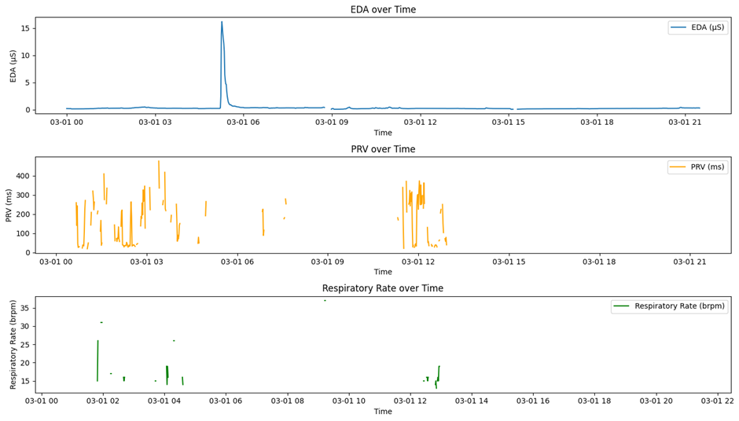

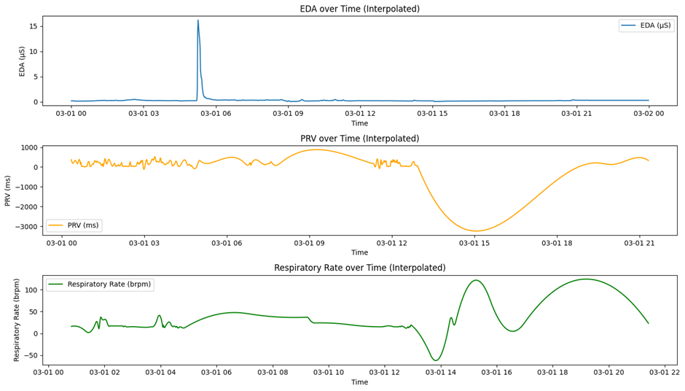

Figure 1. EDA, PRV, and RR data over time on March 01. The peak in EDA around 06:00 indicates heightened arousal or stress, reflected in concurrent PRV drop and RR increase.

**March 02 Observations:**

The EDA, PRV, and RR data for March 02 reveal gradual changes with multiple smaller peaks, suggesting varying levels of stress or arousal throughout the day. The raw data reflects this variability, while the interpolated version accentuates periodic patterns. Notably, peaks in EDA align with dips in PRV and moderate increases in RR, reinforcing the dynamic interplay between autonomic and respiratory functions.

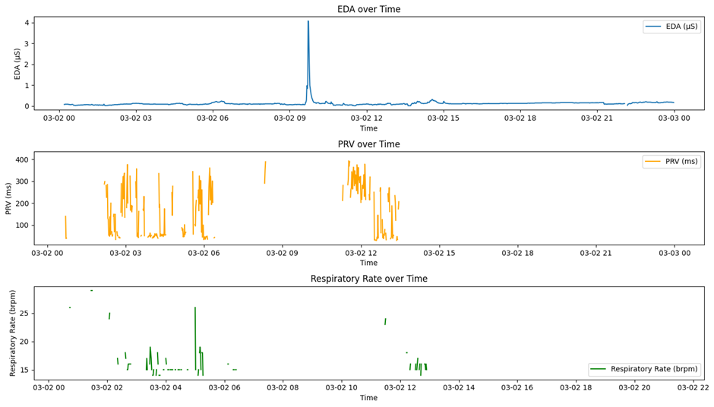

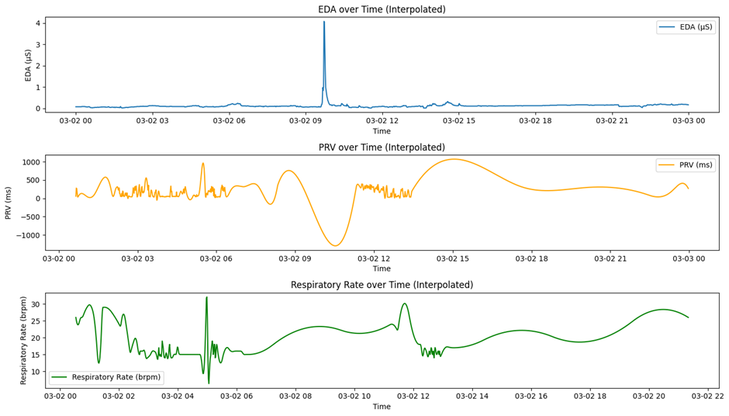

Figure 2. EDA, PRV, and RR data over time on March 02. Gradual fluctuations throughout the day suggest varying stress levels, with peaks in EDA synchronized with PRV and RR shifts.

**March 03 Observations:**

March 03 data represents a relatively calm physiological state, serving as a baseline for comparison. The EDA, PRV, and RR values remain stable with only minor fluctuations, indicating minimal stress reactivity. Interpolated data supports this stability, with low peaks and consistent trends, suggesting a well-regulated autonomic response throughout the day.

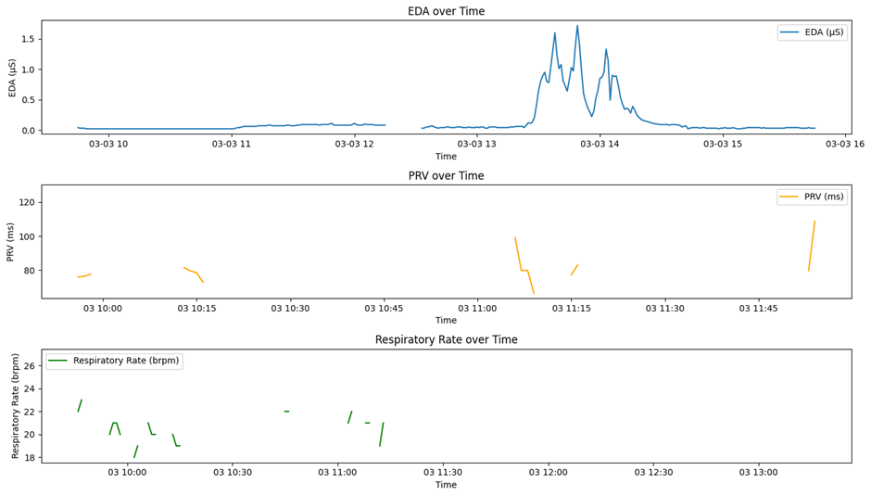

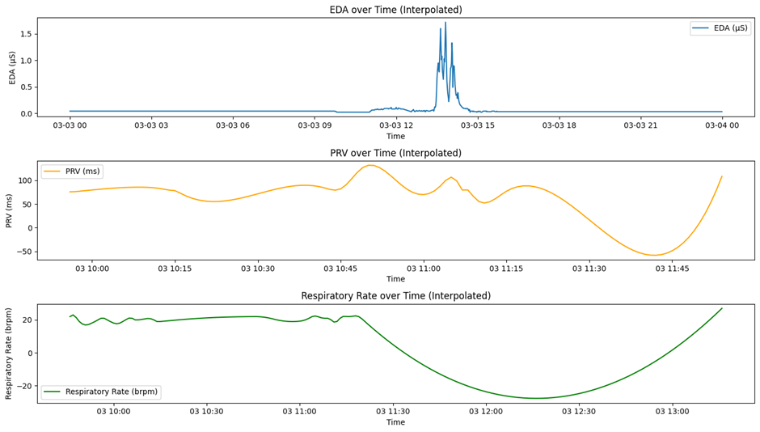

Figure 3. EDA, PRV, and RR data on March 03. The metrics remain stable throughout the day, reflecting a baseline state with minimal physiological disturbance.

**March 05 Observations:**

On March 05, sustained low PRV values were observed between 00:00 and 06:00, indicating prolonged autonomic stress. This period coincides with elevated EDA and a consistently rising RR, potentially linked to continuous stress stimuli or disrupted sleep recovery. The interpolated data smooths the readings, clarifying the extended physiological response during this interval.

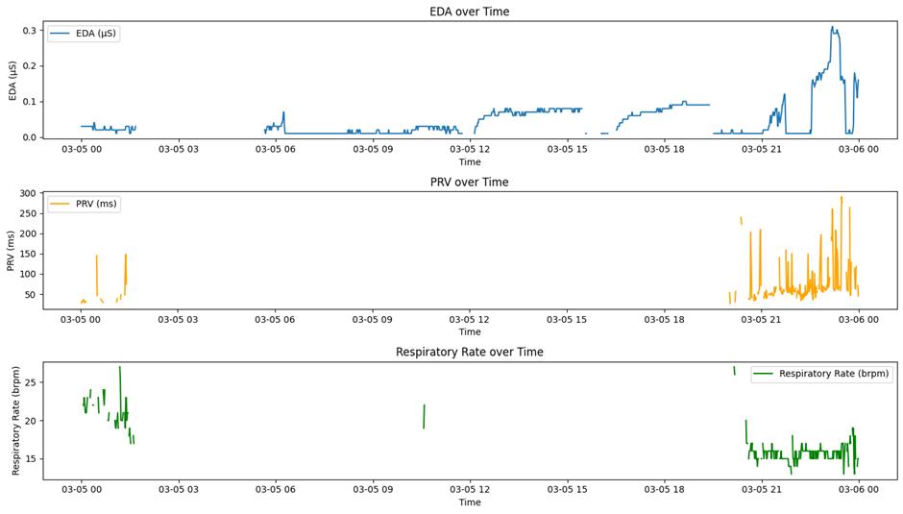

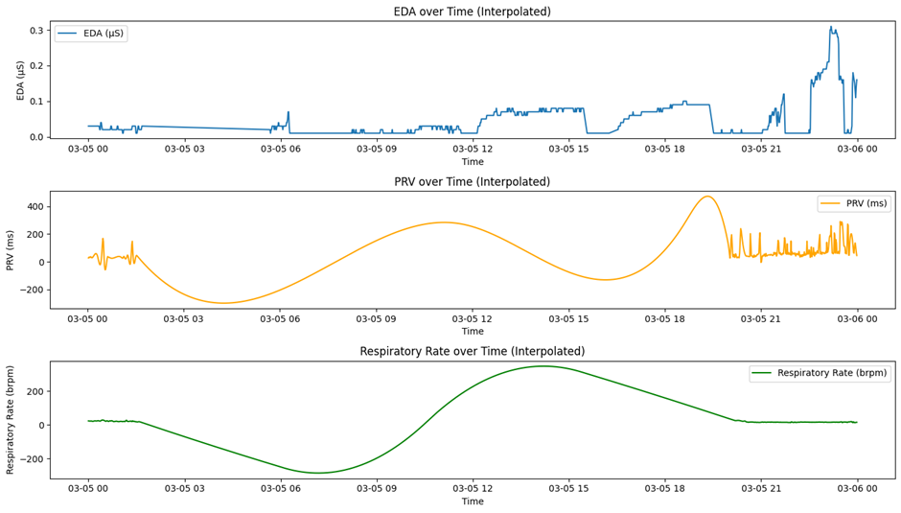

Figure 4. EDA, PRV, and RR data on March 05. A prolonged stress period is observed from 00:00 to 06:00 with low PRV, elevated EDA, and rising RR, possibly indicating overnight stress response.

**March 08 Observations:**

March 08 data highlights intermittent stress responses throughout the day. Periodic peaks in EDA align with dips in PRV and temporary elevations in RR, suggesting episodic stressors, possibly due to external events or daily activities. The interpolated trends emphasize the cyclic pattern, clarifying the synchronization of these physiological changes.

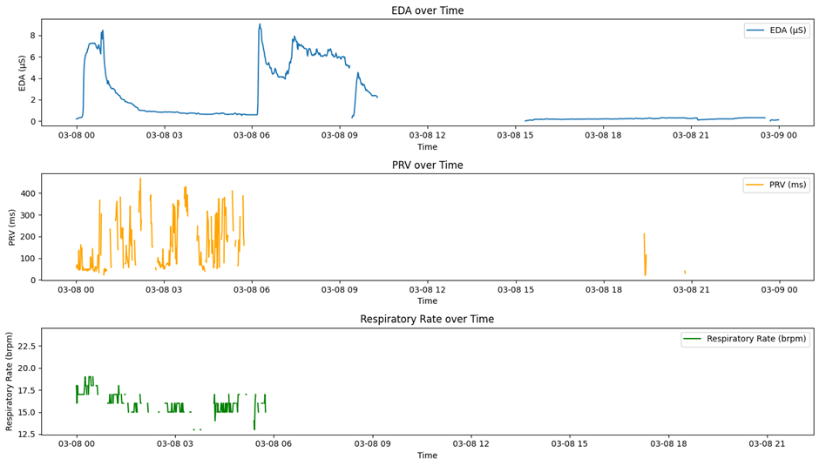

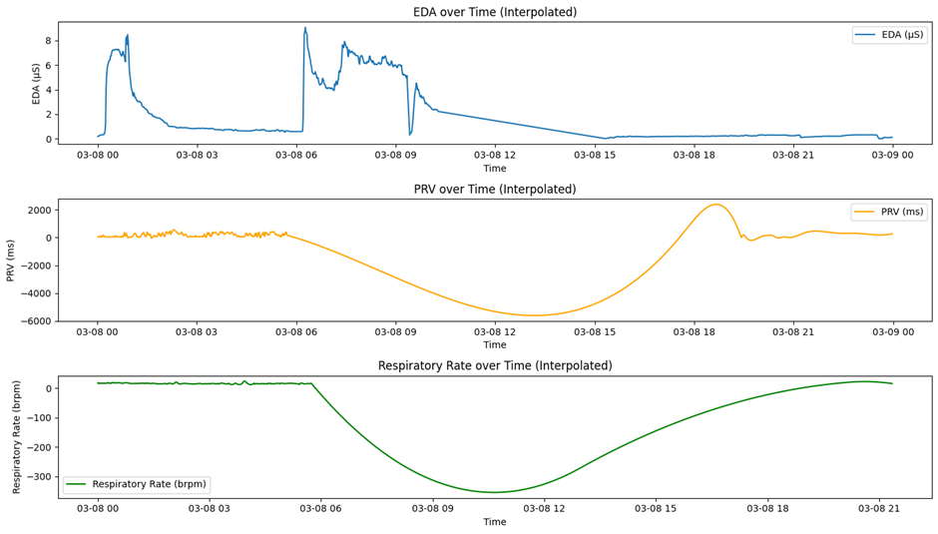

Figure 5. EDA, PRV, and RR data on March 08. Periodic physiological changes reflect episodic stress, with synchronized trends across EDA, PRV, and RR throughout the day.